Web-Development-Lab-Report

**PSYCHOLOGY KNOWLEDGE**

Educational

Report Details

Lab Report Prepared for:

**Md Badiuzzaman Biplob**

Jr. Instructor

Lab Report Prepared by:

**MD Akbar Hossan**

Dept: CMT-4

Roll: 590998

**Jannatul Ferdous Ramisha**

Dept: CTM-4

Roll: 590927

**Roksana Begum**

Dept: CMT-4

Roll: 590978

*About Psychology Knowledge*

Psychology is the scientific study of mind and behavior. Psychology includes the study of conscious and unconscious phenomena, including feelings and thoughts. It is an academic discipline of immense scope, crossing the boundaries between the natural and social sciences. Psychologists seek an understanding of the emergent properties of brains, linking the discipline to neuroscience. As social scientists, psychologists aim to understand the behavior of individuals and groups. The first letter of the Greek word psyche from which the term psychology is derived (see below), is commonly associated with the science.

A professional practitioner or researcher involved in the discipline is called a psychologist. Some psychologists can also be classified as behavioral or cognitive scientists. Some psychologists attempt to understand the role of mental functions in individual and social behavior. Others explore the physiological and neurobiological processes that underlie cognitive functions and behaviors.

Psychologists are involved in research on perception, cognition, attention, emotion, intelligence, subjective experiences, motivation, brain functioning, and personality. Psychologists' interests extend to interpersonal relationships, psychological resilience, family resilience, and other areas within social psychology. They also consider the unconscious mind.[3] Research psychologists employ empirical methods to infer causal and correlational relationships between psychosocial variables. Some, but not all, clinical and counseling psychologists rely on symbolic interpretation.

*Why need Psychology Knowledge?*

The study of psychologically is so widespread today, different sub-disciplines or branches of psychology are widely recognized and frequently leveraged in an array of industries. Some psychology sub-disciplines include:

* **Family** – Family psychology, sometimes known as family therapy, focuses on the interpersonal systems found with the family.
* **Sports** – Sports psychology focuses on how psychology factors can affect an athlete’s performance.
* **Business** – Business psychology focuses on the effectiveness of a workplace or organization through the study of people and overall behavior in the workplace.
* **Media** – Media psychology focuses on the complex relationship between media and its effect on human behavior.
* **Forensic**– Forensic psychology is the practice of studying individuals who are involved in the legal system, such as expert witnesses or those under criminal investigation.

A career in psychology could take multiple trajectories. For example, a modern psychology career could be completely researched-based and non-public facing, or it could be as a family counselor who works with people of all ages each day.

*Included language in this project*

HTML

HTML (Hypertext Markup Language) is the most basic building block of the Web. It defines the meaning and structure of web content. Other technologies besides HTML are generally used to describe a web page's appearance/presentation (CSS) or functionality/behavior (JavaScript).

"Hypertext" refers to links that connect web pages to one another, either within a single website or between websites. Links are a fundamental aspect of the Web. By uploading content to the Internet and linking it to pages created by other people, you become an active participant in the World Wide Web.

CSS

Cascading Style Sheets (CSS) is a style sheet language used for describing the presentation of a document written in a markup language such as HTML or XML (including XML dialects such as SVG, MathML or XHTML).[1] CSS is a cornerstone technology of the World Wide Web, alongside HTML and JavaScript.[2]

CSS is designed to enable the separation of content and presentation, including layout, colors, and fonts.[3] This separation can improve content accessibility; provide more flexibility and control in the specification of presentation characteristics; enable multiple web pages to share formatting by specifying the relevant CSS in a separate.

JavaScript

JavaScript (JS) is a lightweight, interpreted, or just-in-time compiled programming language with first-class functions. While it is most well-known as the scripting language for Web pages, many non-browser environments also use it, such as Node.js, Apache CouchDB and Adobe Acrobat. JavaScript is a prototype-based, multi-paradigm, single-threaded, dynamic language, supporting object-oriented, imperative, and declarative (e.g., functional programming) styles.

Bootstrap

Bootstrap is a free and open-source CSS framework directed at responsive, mobile-first front-end web development. It contains HTML, CSS and JavaScript-based design templates for typography, forms, buttons, navigation, and other interface components. Bootstrap is an HTML, CSS and JS library that focuses on simplifying the development of informative web pages (as opposed to web applications). The primary purpose of adding it to a web project is to apply Bootstrap's choices of color, size, font and layout to that project. In addition, developers can take advantage of CSS classes defined in Bootstrap to further customize the appearance of their contents. For example, Bootstrap has provisioned for light- and dark-colored tables, page headings, more prominent pull quotes, and text with a highlight.

PHP

PHP is a general-purpose scripting language geared toward web development. It was originally created by Danish-Canadian programmer Rasmus Lerdorf in 1993 and released in 1995. The PHP reference implementation is now produced by The PHP Group. PHP was originally an abbreviation of Personal Home Page, but it now stands for the recursive initialism PHP: Hypertext Preprocessor code is usually processed on a web server by a PHP interpreter implemented as a module, a daemon or as a Common Gateway Interface (CGI) executable. PHP can be used for many programming tasks outside the web context, such as standalone graphical applications and robotic drone control. PHP code can also be directly executed from the command line.

MySql

MySQL is an open-source relational database management system. Its name is a combination of "My", the name of co-founder Michael Wideness’s daughter My, and "SQL", the acronym for Structured Query Language. A relational database organizes data into one or more data tables in which data may be related to each other; these relations help structure the data. SQL is a language programmers use to create, modify and extract data from the relational database, as well as control user access to the database. In addition to relational databases and SQL, an RDBMS like MySQL works with an operating system to implement a relational database in a computer's storage system, manages users, allows for network access and facilitates testing database integrity and creation of backups.

**Project Presentation**

Header Section

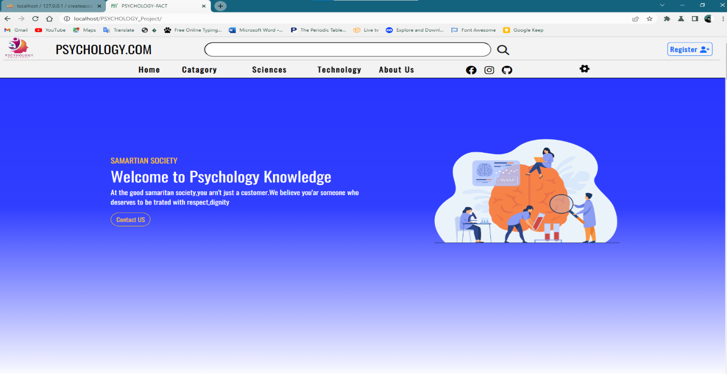

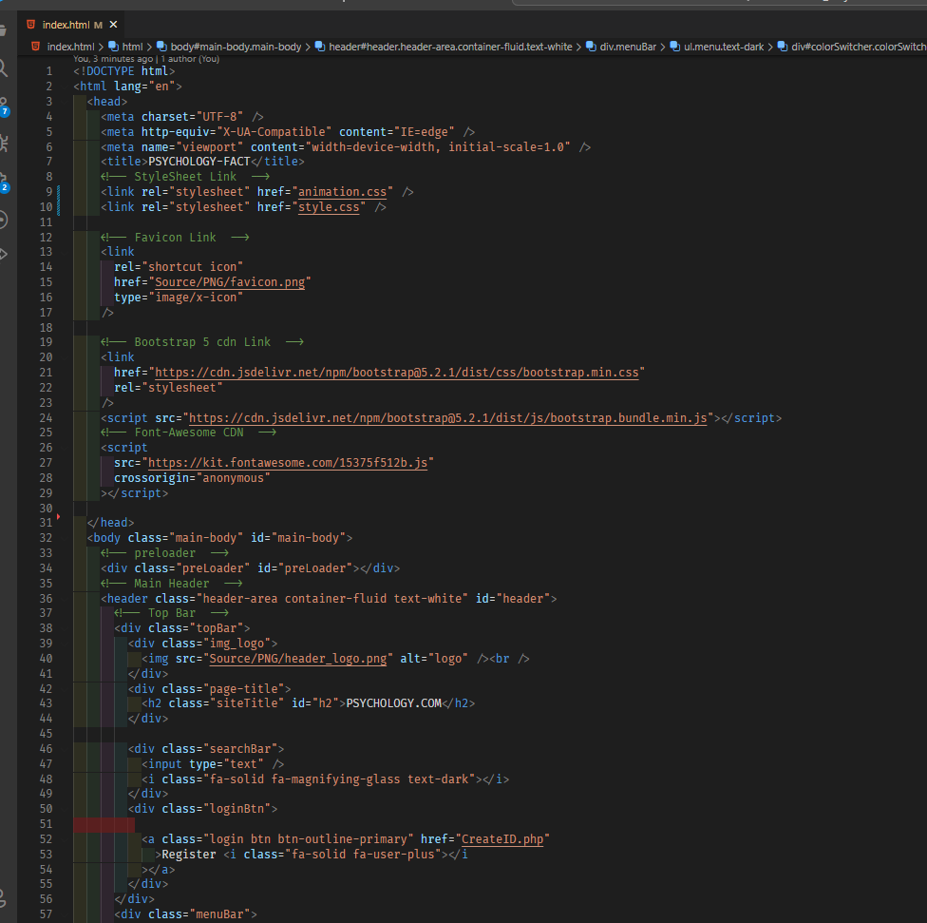

Section-2

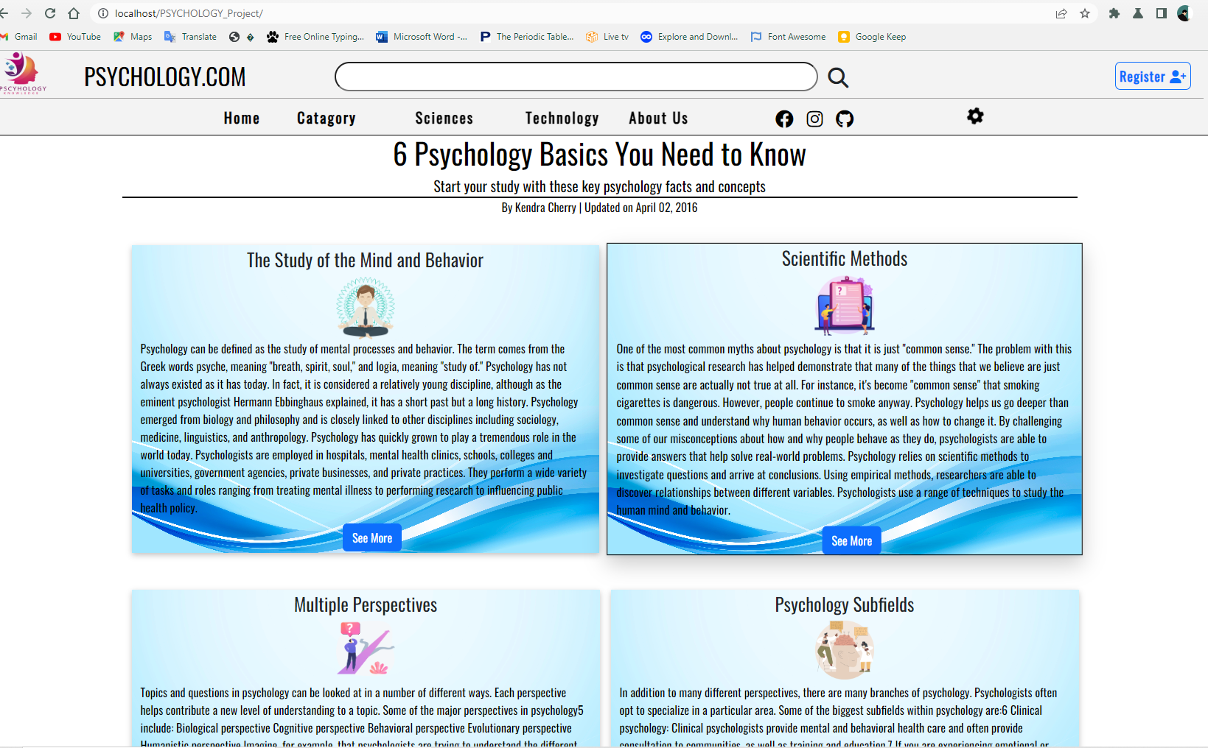

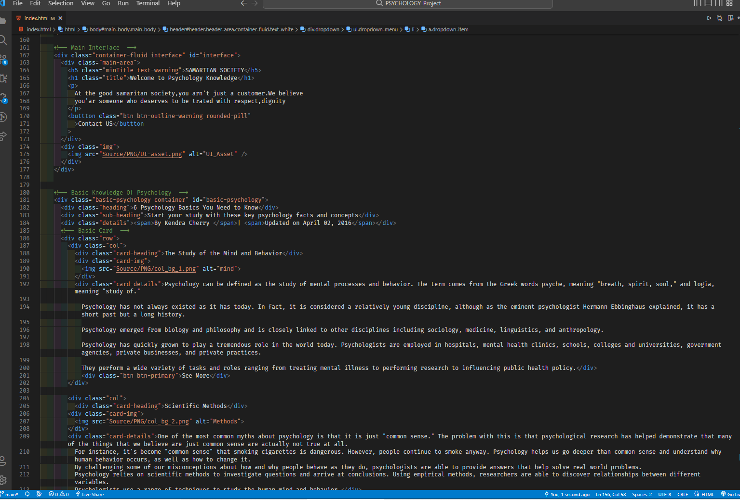

Section-3

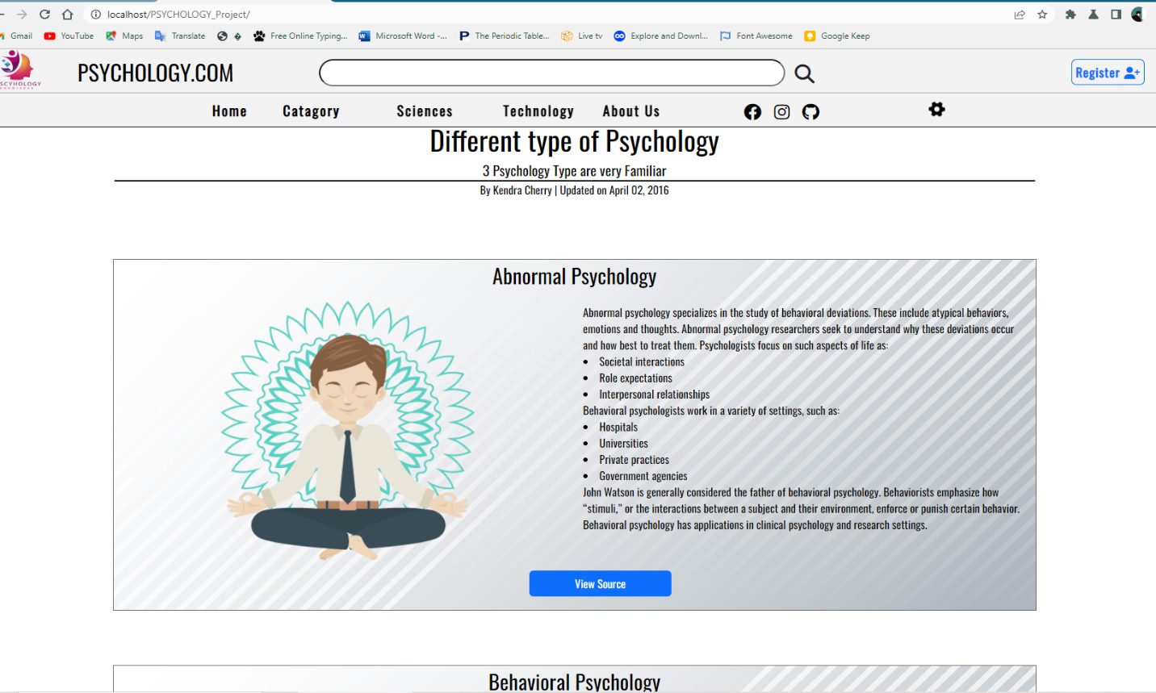

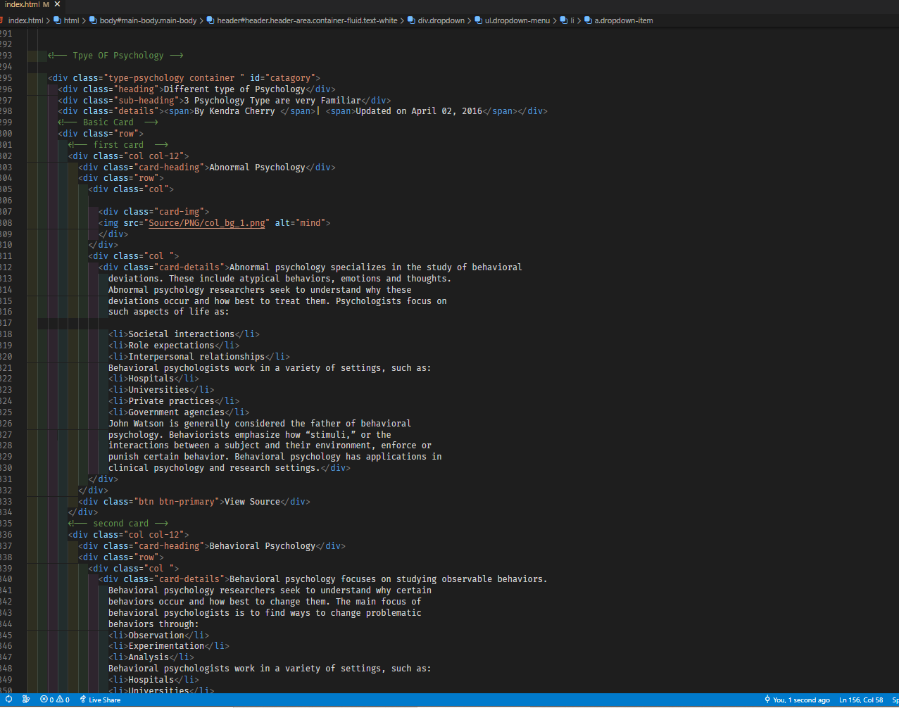

Section-4

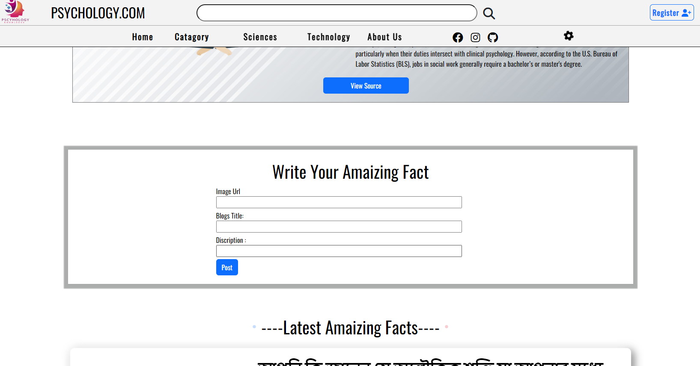

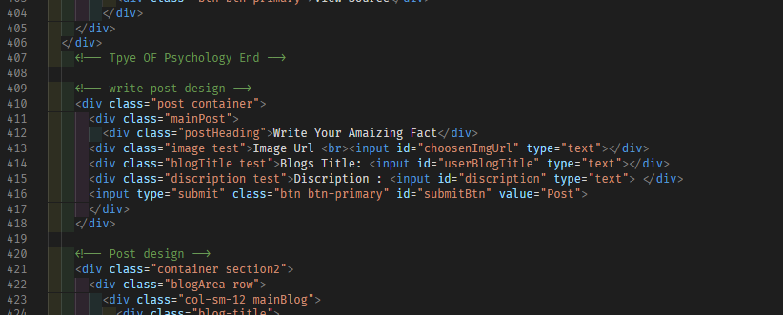

Section-5

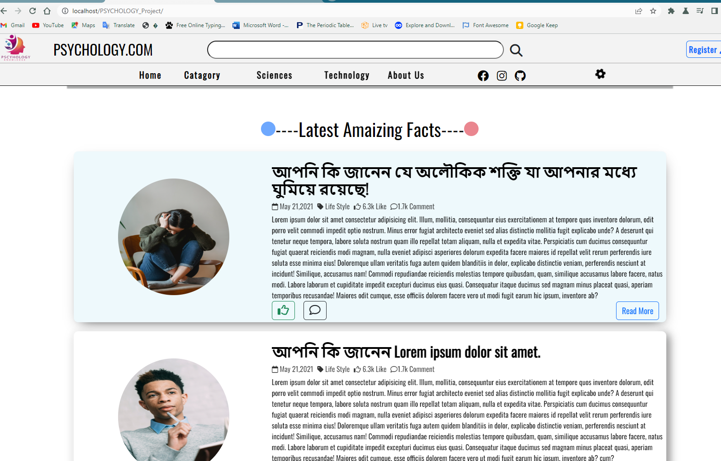

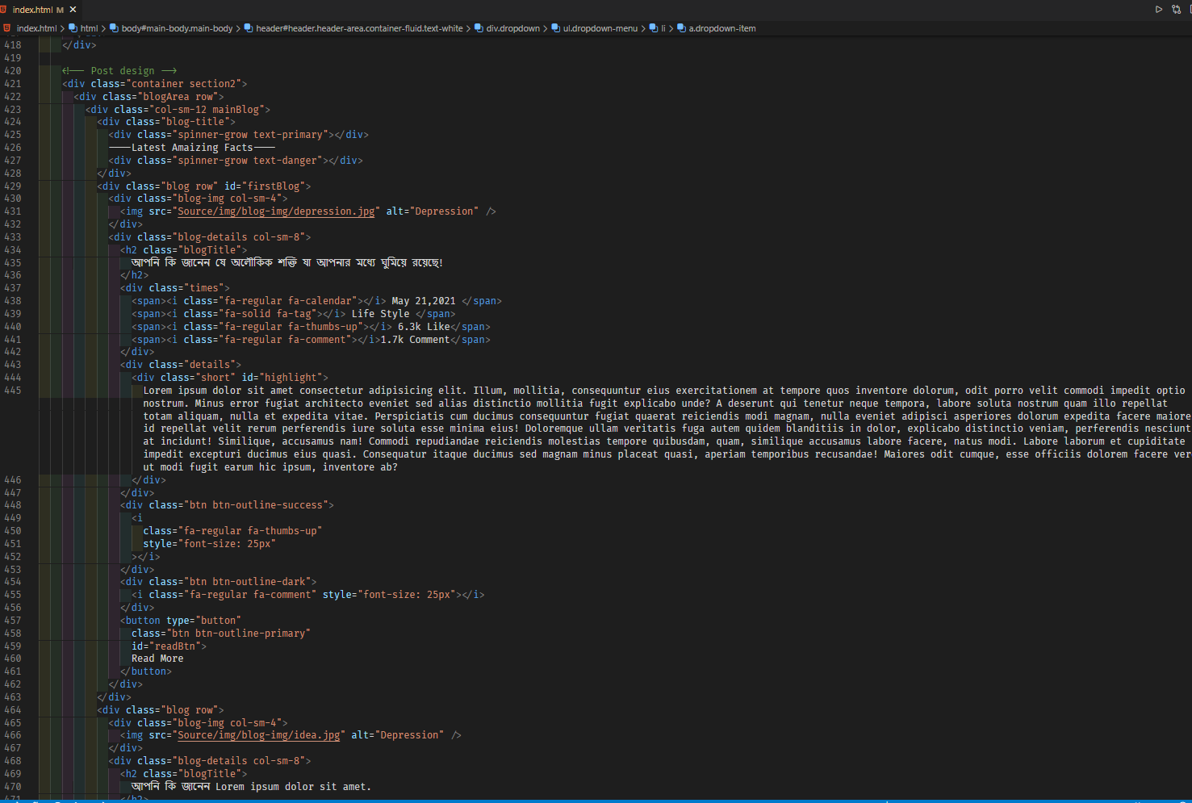

Section-6

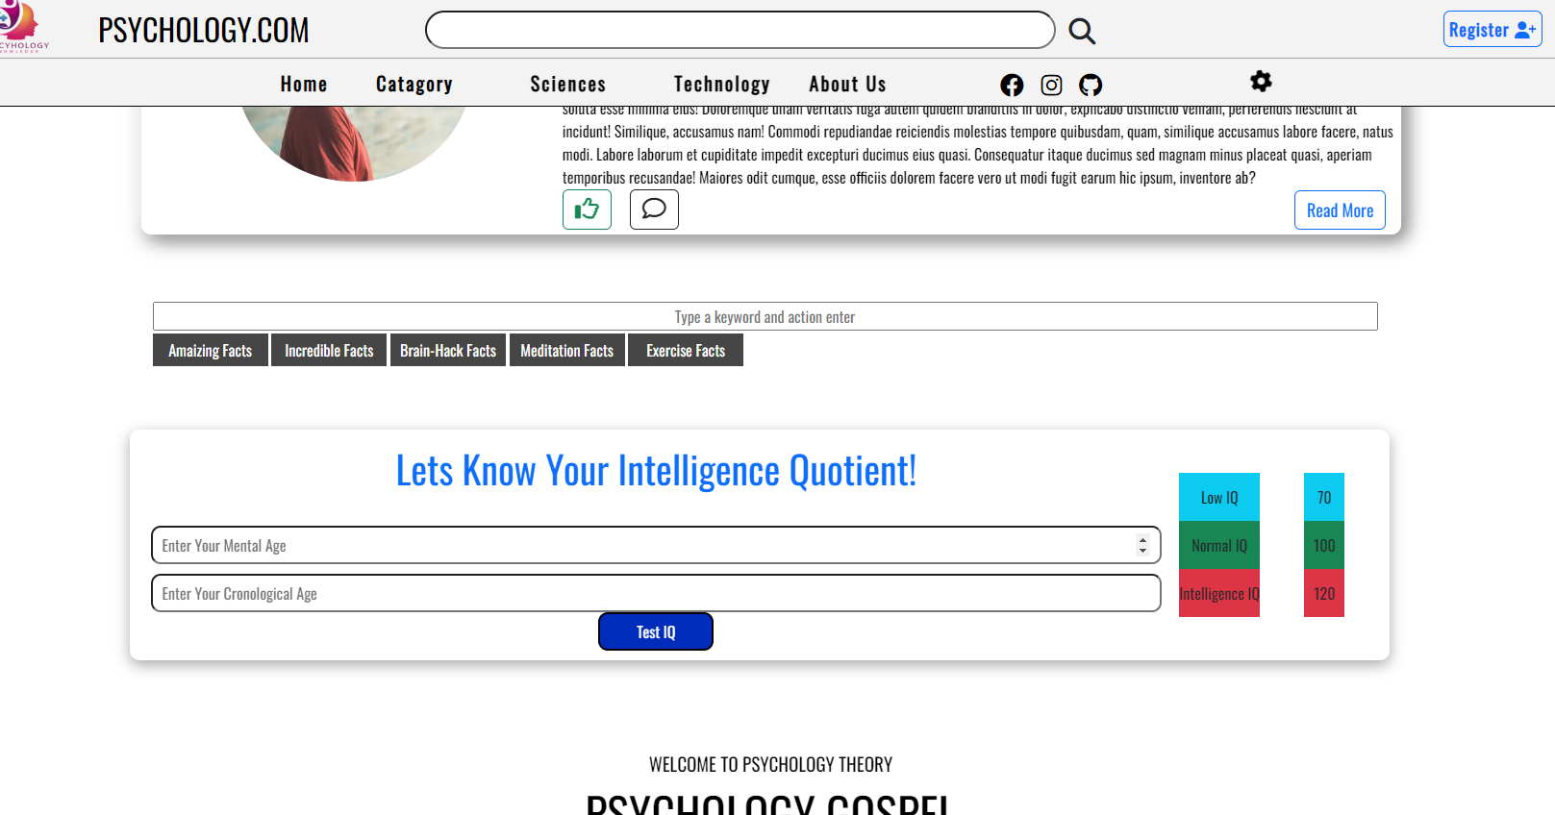

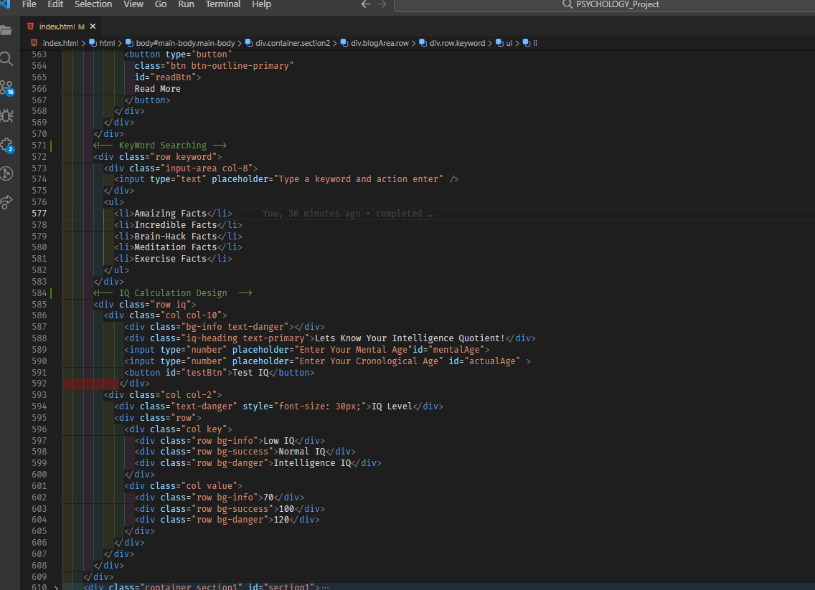

Section-7

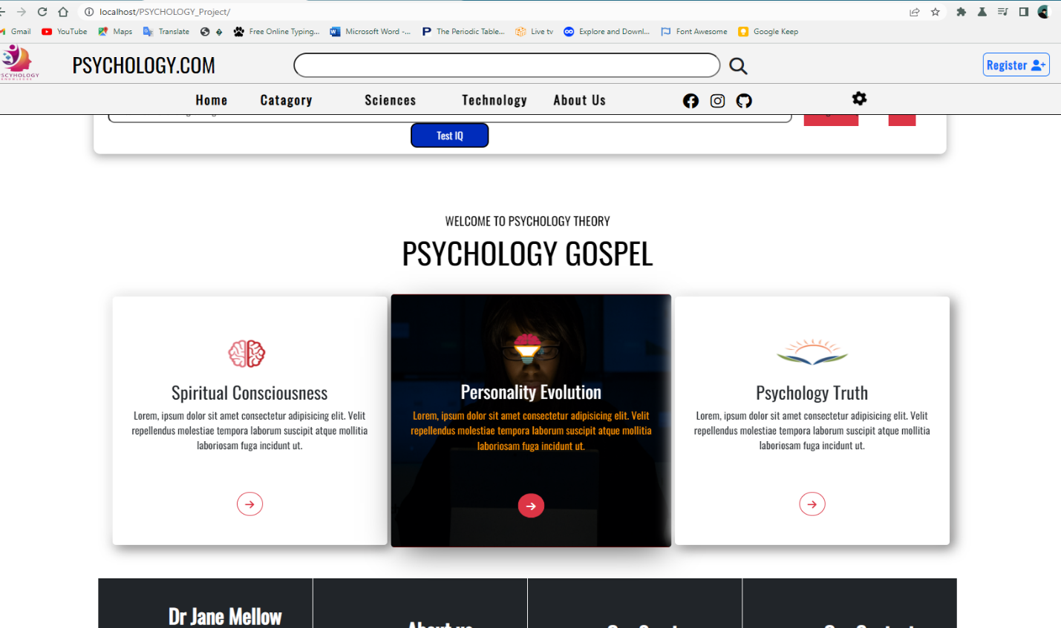

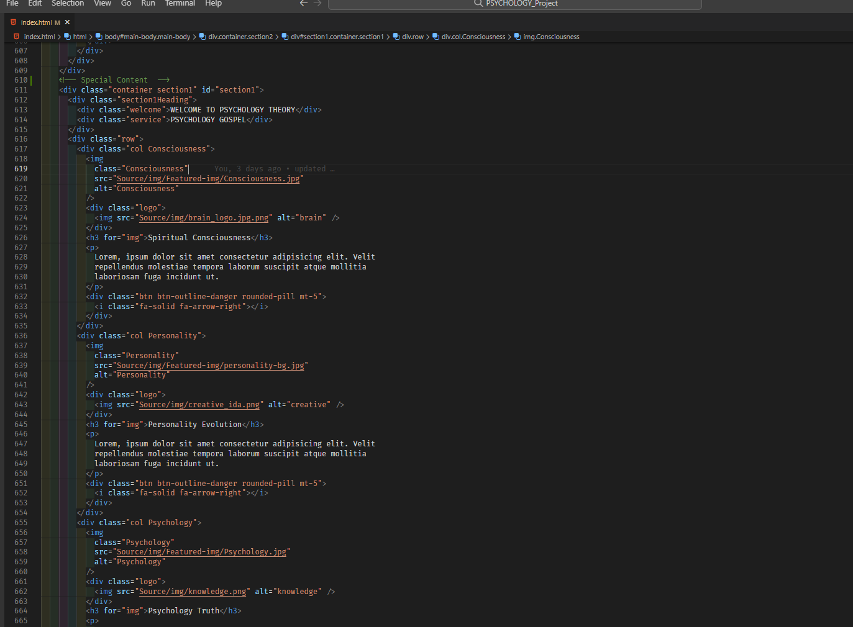

Footer Section

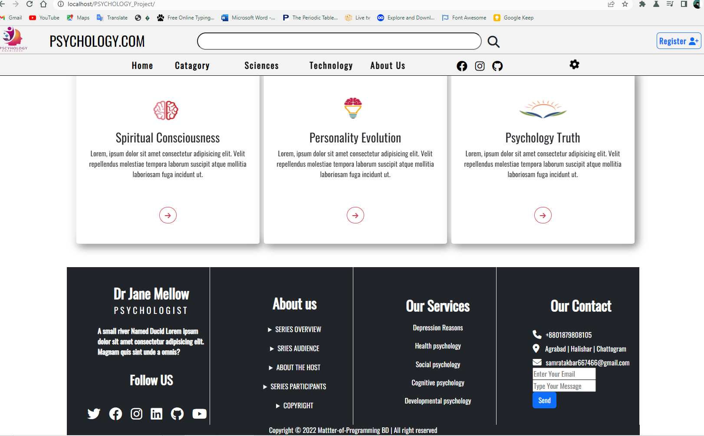

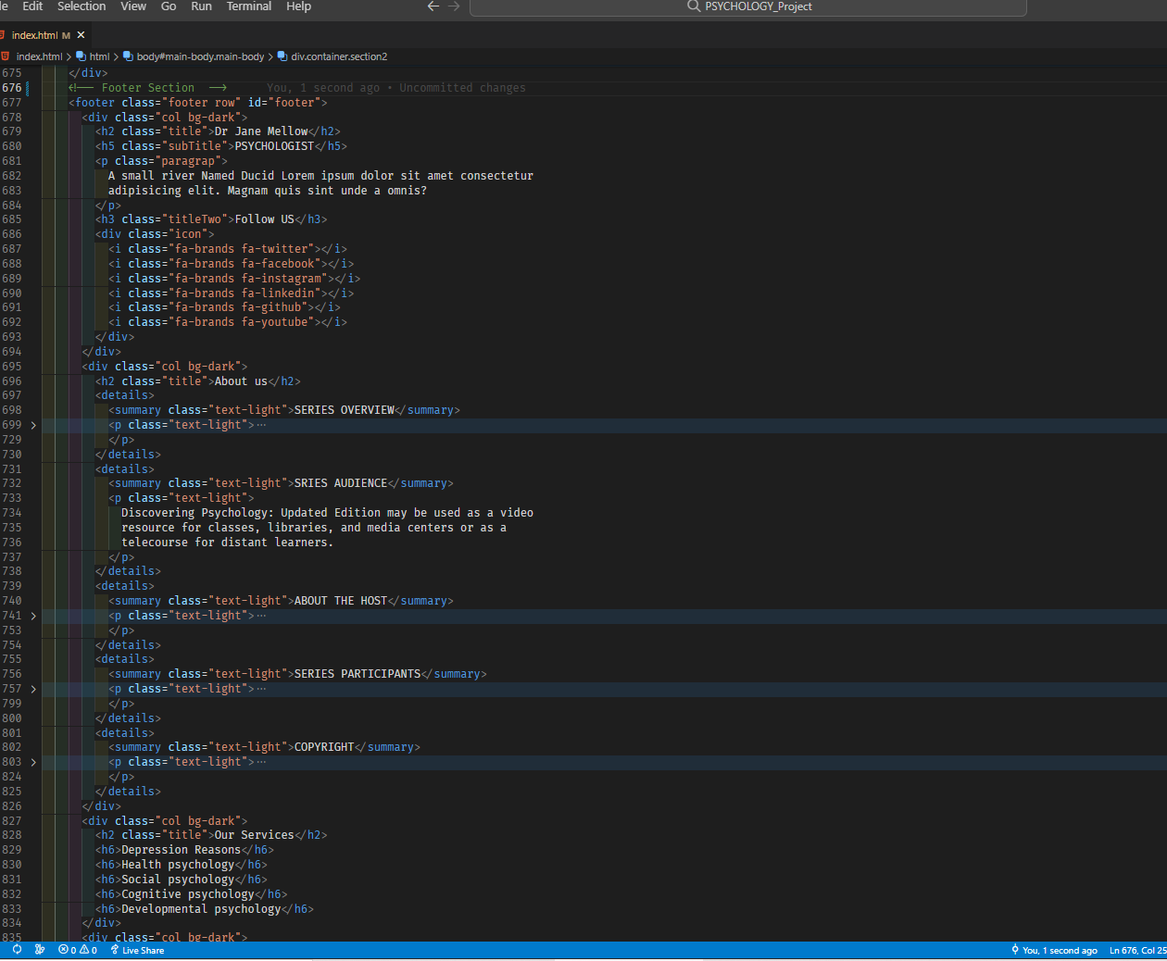

Register Page

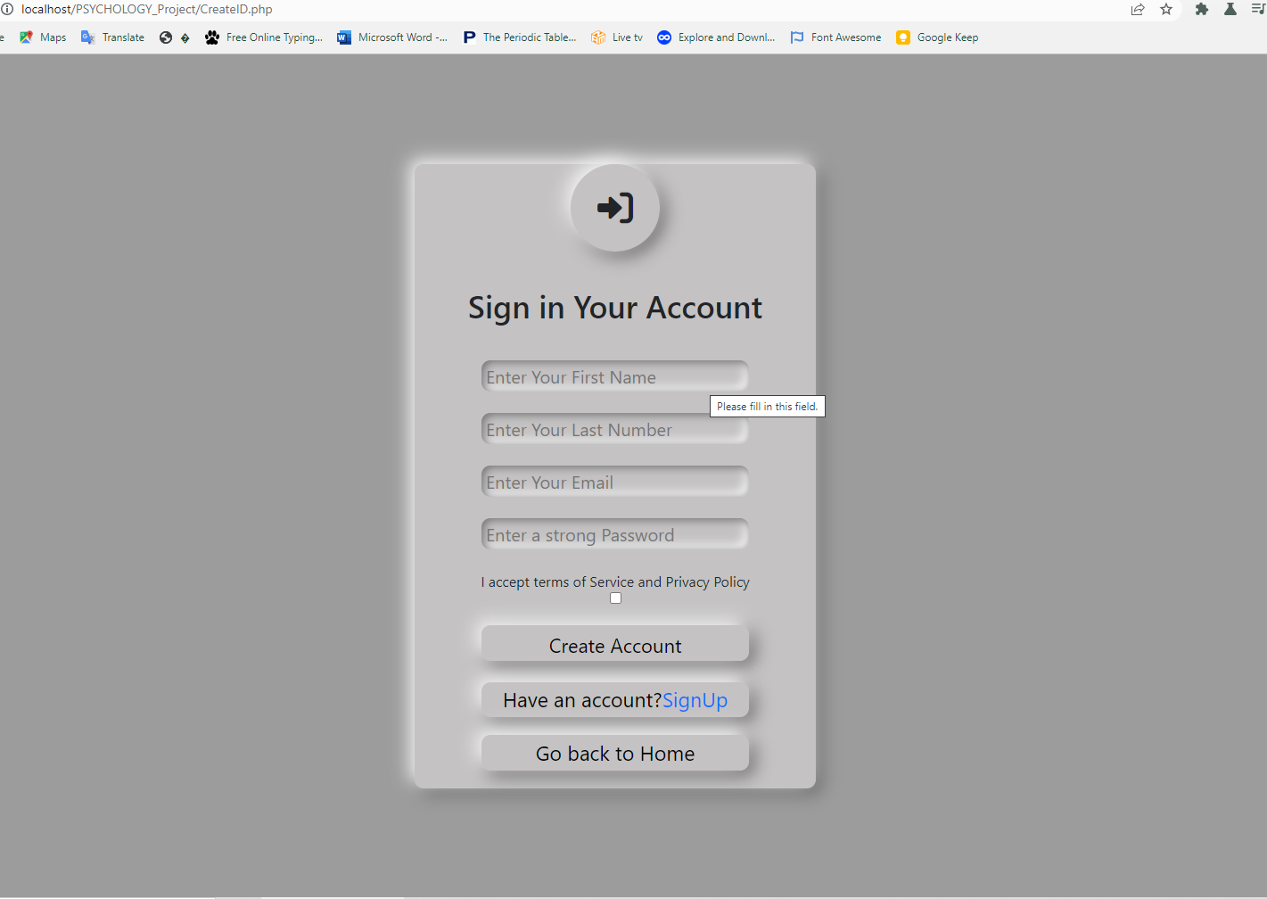

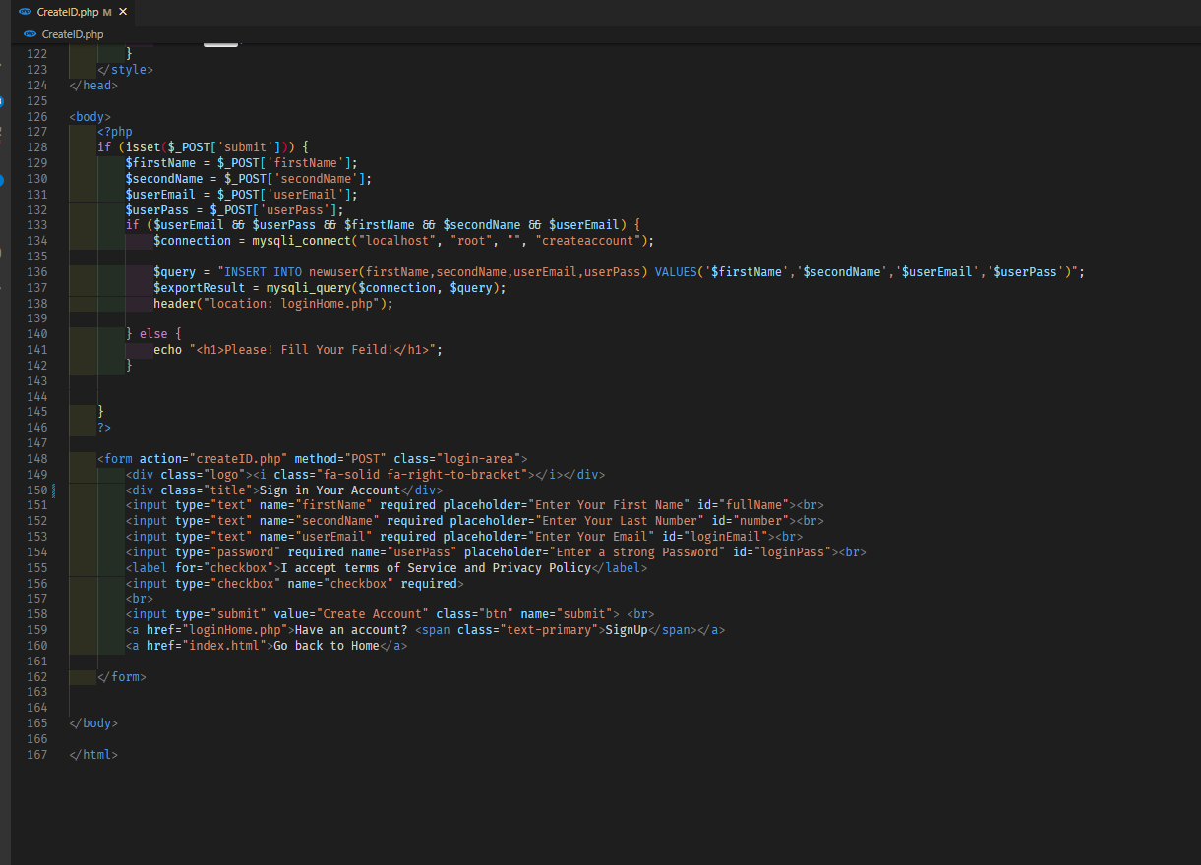

Login Page

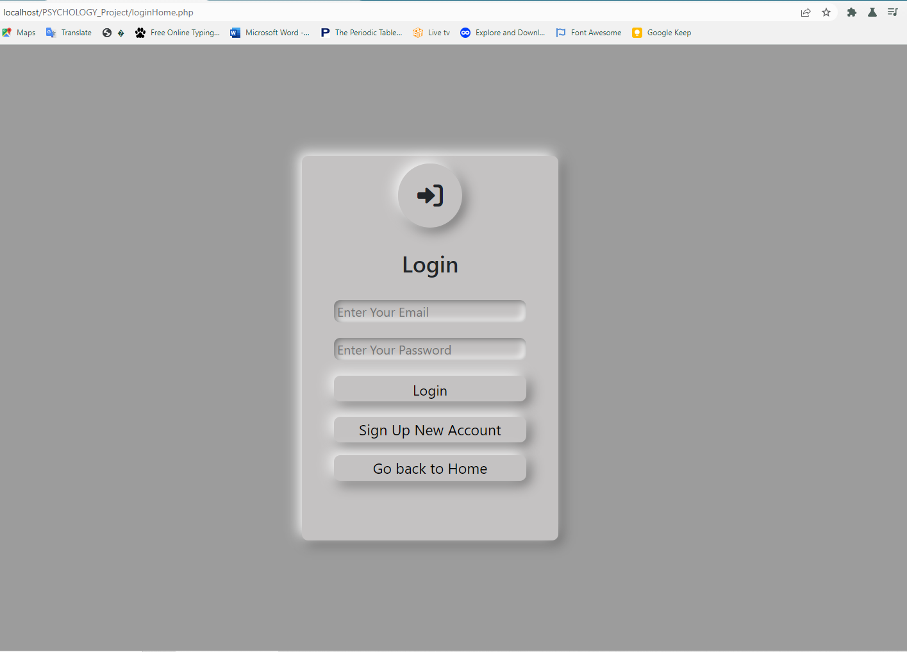

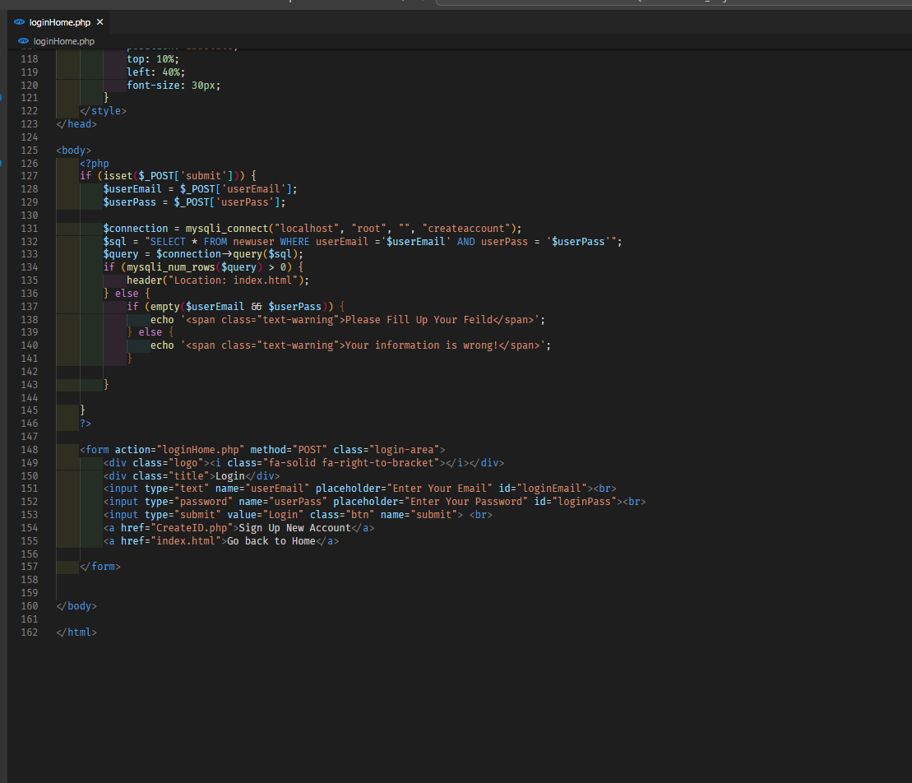

MySql Database

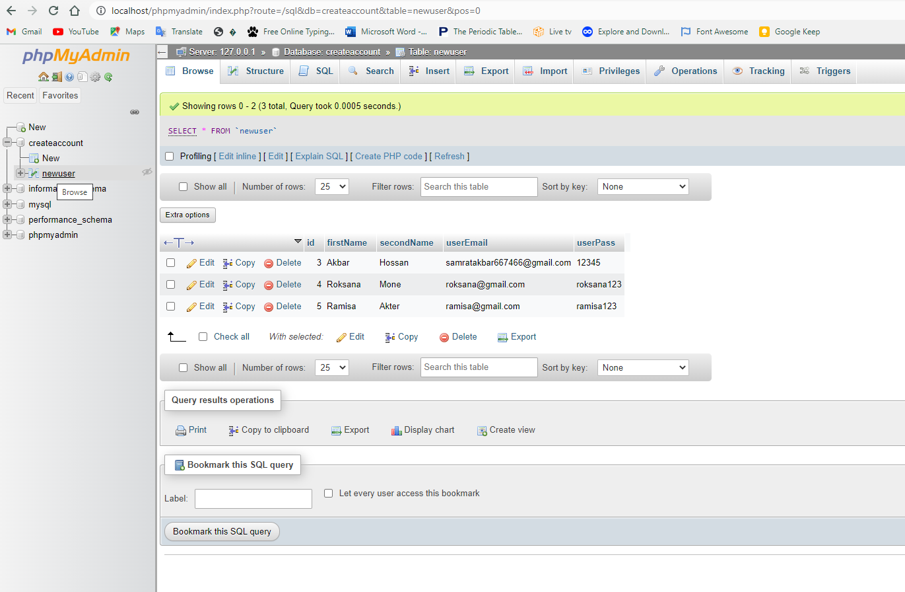

**Our Future Plans**

* We will include more content.
* We will create more page with index.
* We will add more dynamic function.
* We will add some premium feature.
* We will add Review option in Blog.
* We will apply Fully Responsive design.
* We will always up to date.

Thank You!